חלק אחד:

נרצה למצוא את הכוכבים בתמונה בודדת :

נטען את התמונה באמצעות cv2.imread().

נמיר את התמונה כך שבמקום תמונה צבעונית יהיה לנו תמונה בגווני אפור באמצעות cv2.cvtColor().

נרצה לבדוק מה הערכים של הפיקסלים

כל פיקסל כהה (קטן מ209) ימופה ל0 על מנת שנוכל לזהות פיקסלים בהירים (כוכבים) באמצעות cv2.threshold().

נעשה טשטוש לתמונה על מנת להיפטר מרעשים, נשתמש בטשטוש גאוסין שנלמד בעיבוד תמונה והוא הכי יעיל במקרים כאלה, כדי להפחית רעש באמצעות cv2.GaussianBlur().

נמצא את קווי המתאר של הכוכבים באמצעות cv2.findContours().

נמצא את המרכז (x, y) והשטח (רדיוס) של הכוכב באמצעות cv2.moments() וקצת מתמטיקה של נירמול .

נשמור את הקואורדינטות של כל כוכב : המרכז (x, y), הרדיוס והבהירות של הפיקסל הבהיר ביותר לרשימת כוכבים.

נרצה להשתמש בפלט של פונקציה כדי למצוא את הכוכבים החופפים בין שתי תמונות.

אחרי שמיפינו את כל הכוכבים בתמונה אחת נרצה למצוא התאמה של כוכבים בין 2 תמונות:

נרצה לקבל שני נתיבים של התמונות

נמצא את הכוכבים מהקוד שכתבנו בחלק הראשון

לאחר מכן נרצה למצוא כוכבים זהים דרך הרעיון של אלגוריתם RANSAC:

האלגוריתם יפעל באיטרציות על כל הכוכבים בתמונה הראשונה על ידי זה שהוא ימצא עבור כל כוכב בתמונה הראשונה את הכוכב הקרוב ביותר בתמונה השנייה.

נרצה לחשב את המרחק בין הכוכבים בשני התמונות על ידי שימוש במרחב אוקלידי:

מרחב אוקלידי:

הגדרה של מישור אוקלידי ומרחב אוקלידי:

המישור האוקלידי על קבוצה של נקודות המקיימות קשרים מסוימים, שאפשר לבטא אותם במונחים של מרחק וזווית. לדוגמה, יש שתי פעולות בסיסיות במישור. האחת היא העתקה, כלומר הזזה של המישור כך שכל הנקודות בו יזוזו באותו כיוון ולאותו מרחק. האחרת היא סיבוב סביב נקודה קבועה במישור, כך שכל הנקודות במישור יזוזו באותה זווית יחסית לנקודה הקבועה. אחד מיסודות הגאומטריה האוקלידית הוא ששני גופים במישור, כלומר, תת-קבוצות של המישור, נחשבים שקולים (חופפים) אם אפשר לעבור מהאחד אל האחר בדרך של העתקות, סיבובים ושיקופים.

שימוש ברחב אוקלידי זה בדיוק מה שהיינו רוצים לעשות על מנת למצוא כוכבים חופפים.

החישוב נעשה על ידי הפחתת המיקום וליקחת המרחק האוקלידי כמו שמתואר בווידקיפדיה:

https://he.wikipedia.org/wiki/%D7%9E%D7%A8%D7%97%D7%91_%D7%90%D7%95%D7%A7%D7%9C%D7%99%D7%93%D7%99

אם ההפרש של בין התמונות קטן מ200 אז הם יחשבו כוכבים חופפים ונשמור אותם .

נדגים עבור מספר רב של תמונות להראות שהאלגוריתם עובד:

עבור כל זוג תמונות הפלטים מתוארים כך: a הכוכבים שנמצאו בתמונה 1 , b הכוכבים שנמצאו בתמונה 2 ולאחר מכך פלט במייצג את הכוכבים המשותפים.

חלק רביעי:

נבדקו הרבה תמונות אבל כאן נראה רק מקרים חשובים ואת התוצאות שלהם:

כל התמונות שנבדקו נבדקו תמונות שהם בגדלים שונים , וחלק זהים

1. תמונות שהבסיס של הכוכבים הזהים צולמו כביכול כאשר "סובבו" את המצלמה ונוספו כוכבים חדשים על מנת לבלבל
2. תמונות שהם זהות אך בכלל הבהירות בשמיים כביכול יש כוכבים "שנעלמו" , והתמונה עצמה היא בגודל שונה כך שלא כל הכוכבים נמצאים באותו המיקום
3. תמונות מפוברקות שהכוכבים בזוויות שונות ונוספו כוכבים חדשים

נראה דוגמות לכל המקרים האלא:

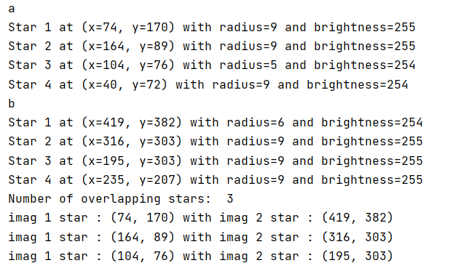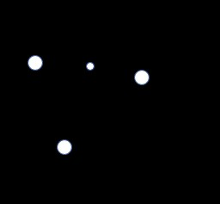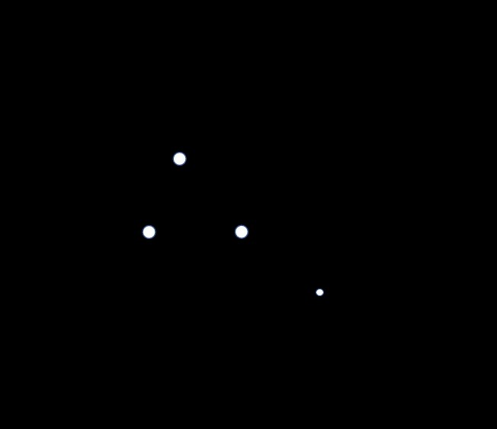

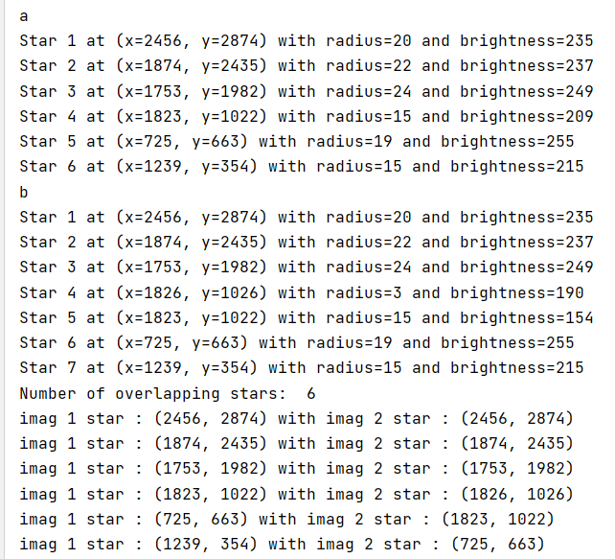

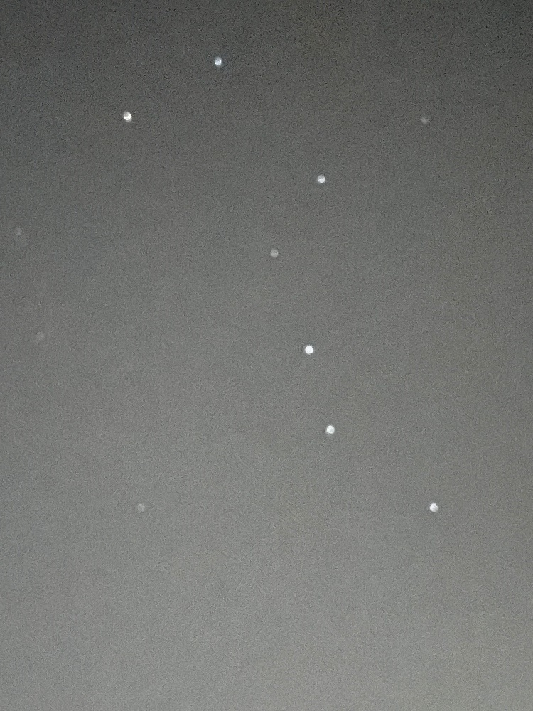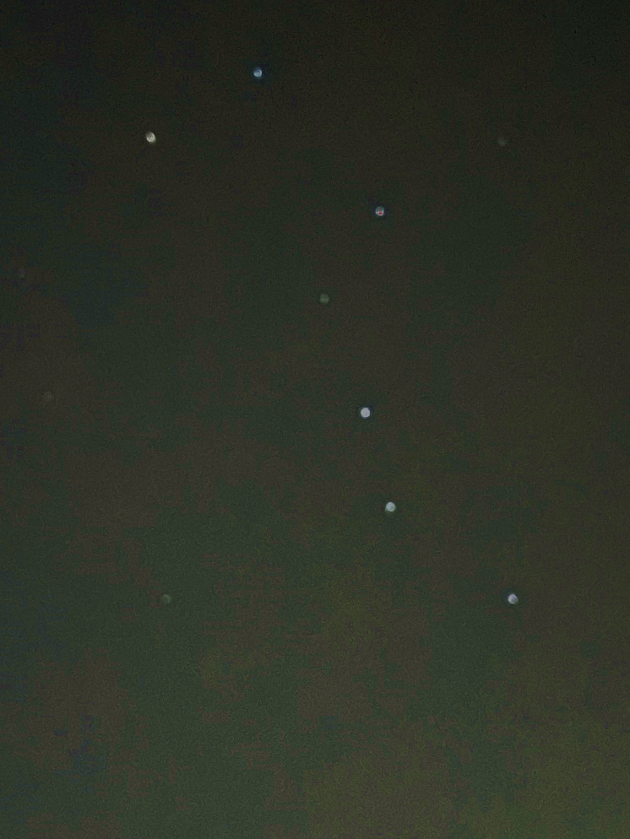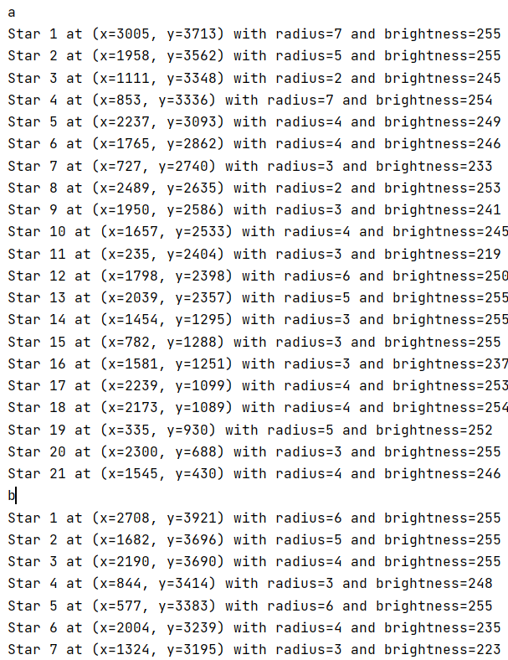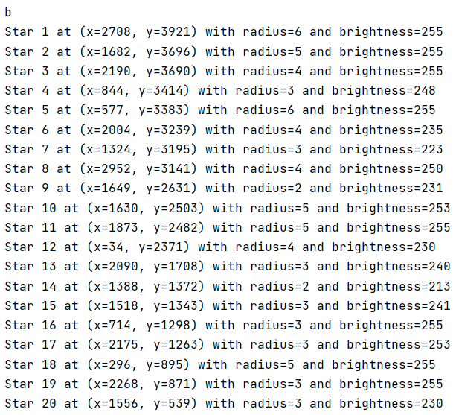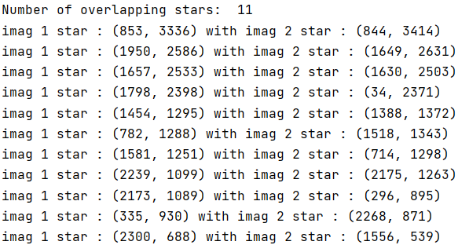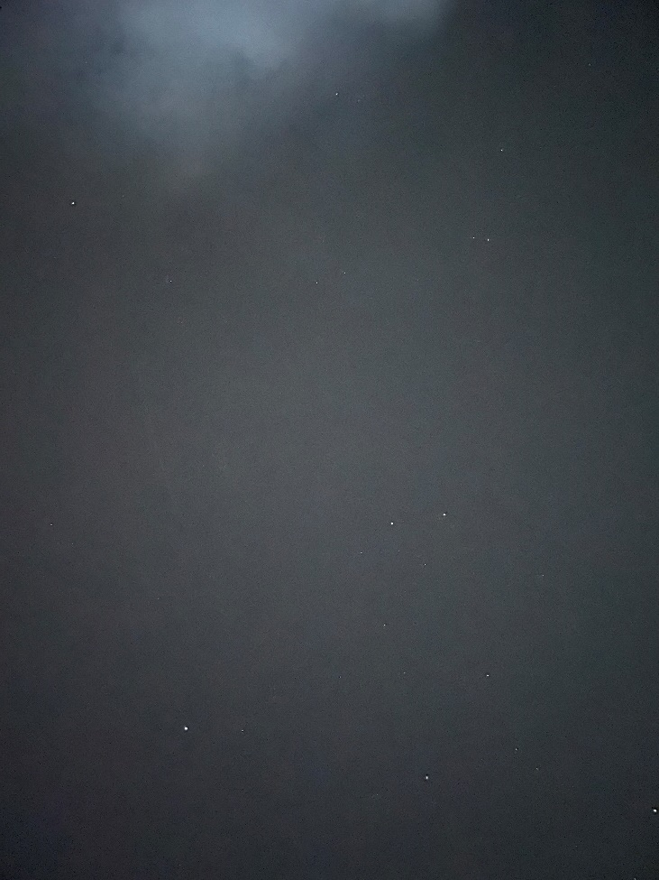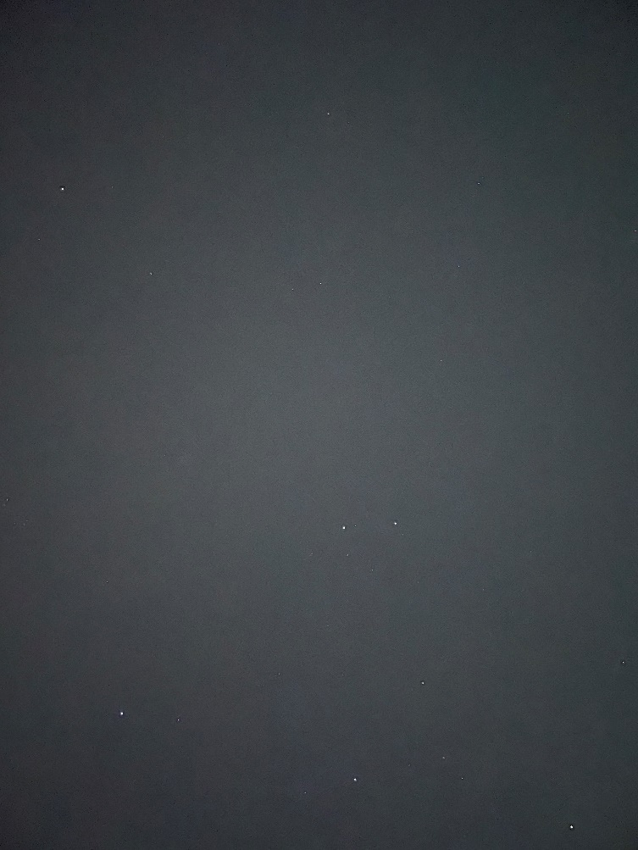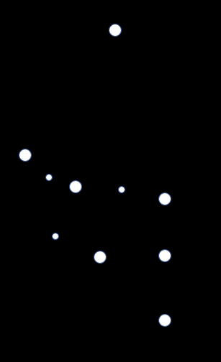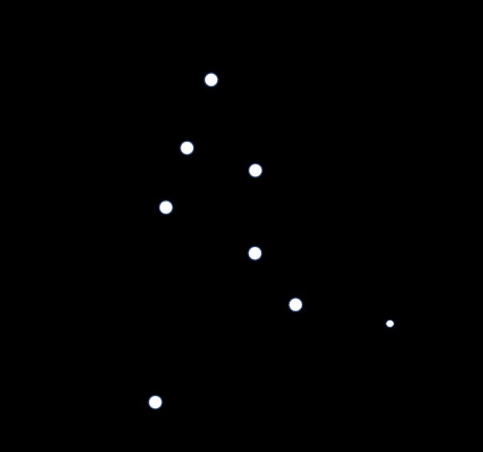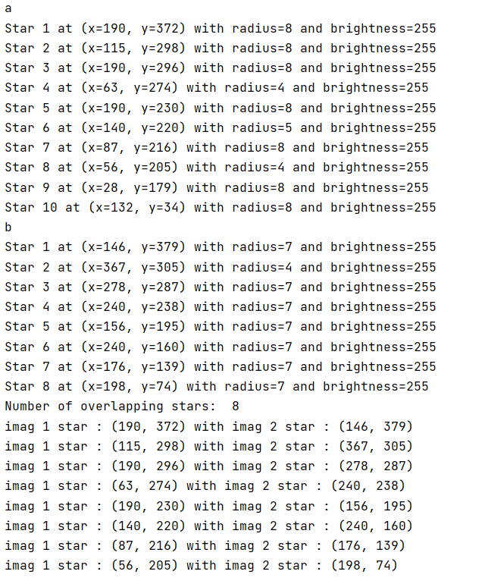

2 התמונות שהעלת לנו בקובץ זיפ כמה ימים לפני ההגשה:

a

Star 1 at (x=102, y=1217) with radius=3 and brightness=254

Star 2 at (x=528, y=1198) with radius=3 and brightness=253

Star 3 at (x=1455, y=1183) with radius=5 and brightness=255

Star 4 at (x=752, y=1179) with radius=3 and brightness=252

Star 5 at (x=529, y=1178) with radius=2 and brightness=222

Star 6 at (x=226, y=1149) with radius=3 and brightness=255

Star 7 at (x=1235, y=1146) with radius=3 and brightness=255

Star 8 at (x=882, y=1145) with radius=5 and brightness=255

Star 9 at (x=1892, y=1138) with radius=7 and brightness=255

Star 10 at (x=1911, y=1128) with radius=3 and brightness=255

Star 11 at (x=903, y=1115) with radius=3 and brightness=255

Star 12 at (x=1031, y=1109) with radius=3 and brightness=227

Star 13 at (x=162, y=1078) with radius=2 and brightness=255

Star 14 at (x=1218, y=1070) with radius=3 and brightness=255

Star 15 at (x=368, y=1059) with radius=3 and brightness=255

Star 16 at (x=1813, y=1056) with radius=3 and brightness=255

Star 17 at (x=674, y=1051) with radius=3 and brightness=255

Star 18 at (x=657, y=1034) with radius=3 and brightness=252

Star 19 at (x=1794, y=1034) with radius=5 and brightness=255

Star 20 at (x=1545, y=1015) with radius=6 and brightness=255

Star 21 at (x=1422, y=1002) with radius=3 and brightness=255

Star 22 at (x=526, y=1004) with radius=7 and brightness=255

Star 23 at (x=710, y=997) with radius=3 and brightness=253

Star 24 at (x=343, y=978) with radius=4 and brightness=254

Star 25 at (x=192, y=975) with radius=4 and brightness=255

Star 26 at (x=364, y=966) with radius=3 and brightness=247

Star 27 at (x=1140, y=942) with radius=4 and brightness=255

Star 28 at (x=1638, y=934) with radius=3 and brightness=255

Star 29 at (x=477, y=924) with radius=6 and brightness=254

Star 30 at (x=1315, y=911) with radius=4 and brightness=254

Star 31 at (x=1158, y=902) with radius=3 and brightness=255

Star 32 at (x=73, y=895) with radius=4 and brightness=254

Star 33 at (x=1146, y=889) with radius=4 and brightness=255

Star 34 at (x=441, y=871) with radius=4 and brightness=254

Star 35 at (x=1384, y=868) with radius=3 and brightness=247

Star 36 at (x=1216, y=866) with radius=3 and brightness=227

Star 37 at (x=628, y=856) with radius=3 and brightness=233

Star 38 at (x=777, y=840) with radius=5 and brightness=253

Star 39 at (x=389, y=834) with radius=3 and brightness=254

Star 40 at (x=767, y=799) with radius=3 and brightness=253

Star 41 at (x=1891, y=789) with radius=3 and brightness=243

Star 42 at (x=1670, y=766) with radius=3 and brightness=253

Star 43 at (x=1219, y=766) with radius=6 and brightness=253

Star 44 at (x=206, y=755) with radius=3 and brightness=255

Star 45 at (x=1059, y=745) with radius=3 and brightness=253

Star 46 at (x=9, y=717) with radius=3 and brightness=244

Star 47 at (x=1223, y=702) with radius=3 and brightness=254

Star 48 at (x=1606, y=681) with radius=4 and brightness=255

Star 49 at (x=1044, y=677) with radius=7 and brightness=255

Star 50 at (x=1577, y=667) with radius=3 and brightness=255

Star 51 at (x=354, y=653) with radius=3 and brightness=254

Star 52 at (x=160, y=636) with radius=3 and brightness=245

Star 53 at (x=724, y=632) with radius=3 and brightness=249

Star 54 at (x=1193, y=628) with radius=3 and brightness=251

Star 55 at (x=582, y=611) with radius=5 and brightness=230

Star 56 at (x=598, y=595) with radius=3 and brightness=251

Star 57 at (x=985, y=589) with radius=3 and brightness=255

Star 58 at (x=1461, y=580) with radius=3 and brightness=255

Star 59 at (x=134, y=573) with radius=4 and brightness=254

Star 60 at (x=991, y=560) with radius=6 and brightness=255

Star 61 at (x=1470, y=556) with radius=3 and brightness=250

Star 62 at (x=895, y=489) with radius=3 and brightness=236

Star 63 at (x=302, y=486) with radius=3 and brightness=255

Star 64 at (x=1591, y=483) with radius=3 and brightness=251

Star 65 at (x=1842, y=475) with radius=4 and brightness=255

Star 66 at (x=533, y=471) with radius=3 and brightness=237

Star 67 at (x=526, y=461) with radius=4 and brightness=253

Star 68 at (x=1844, y=441) with radius=3 and brightness=254

Star 69 at (x=1502, y=443) with radius=6 and brightness=255

Star 70 at (x=912, y=422) with radius=5 and brightness=254

Star 71 at (x=1736, y=415) with radius=3 and brightness=253

Star 72 at (x=1075, y=397) with radius=3 and brightness=255

Star 73 at (x=453, y=358) with radius=3 and brightness=245

Star 74 at (x=256, y=355) with radius=2 and brightness=236

Star 75 at (x=1378, y=343) with radius=3 and brightness=255

Star 76 at (x=278, y=339) with radius=2 and brightness=230

Star 77 at (x=1822, y=333) with radius=3 and brightness=255

Star 78 at (x=732, y=332) with radius=2 and brightness=255

Star 79 at (x=1225, y=323) with radius=3 and brightness=235

Star 80 at (x=899, y=299) with radius=3 and brightness=220

Star 81 at (x=963, y=299) with radius=6 and brightness=254

Star 82 at (x=522, y=286) with radius=3 and brightness=255

Star 83 at (x=1431, y=277) with radius=3 and brightness=248

Star 84 at (x=1614, y=265) with radius=2 and brightness=213

Star 85 at (x=297, y=266) with radius=3 and brightness=255

Star 86 at (x=657, y=261) with radius=6 and brightness=255

Star 87 at (x=486, y=245) with radius=3 and brightness=253

Star 88 at (x=1266, y=197) with radius=3 and brightness=255

Star 89 at (x=1101, y=185) with radius=4 and brightness=255

Star 90 at (x=1749, y=172) with radius=4 and brightness=255

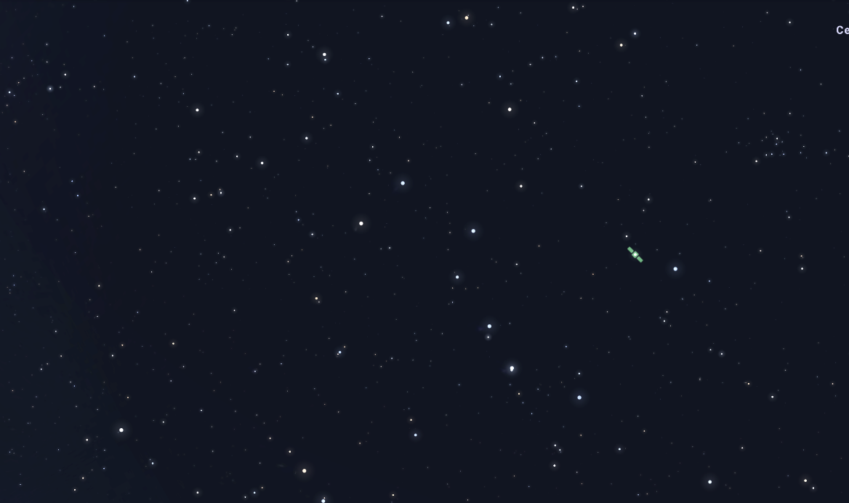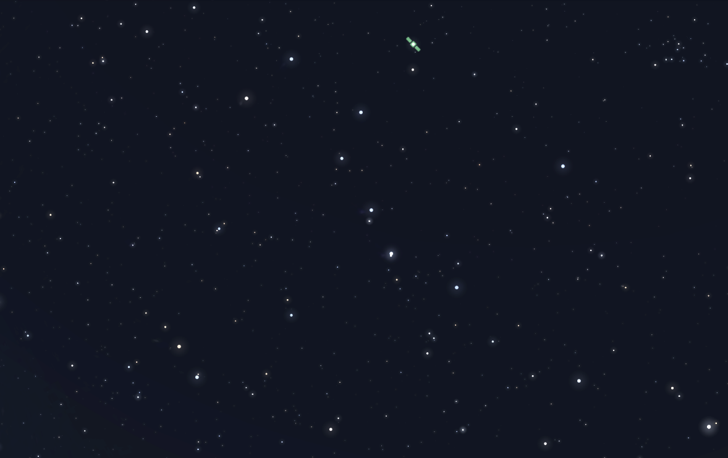

Star 91 at (x=1940, y=170) with radius=3 and brightness=254

Star 92 at (x=247, y=167) with radius=3 and brightness=253

Star 93 at (x=274, y=162) with radius=4 and brightness=255

Star 94 at (x=1825, y=161) with radius=3 and brightness=255

Star 95 at (x=1582, y=158) with radius=2 and brightness=244

Star 96 at (x=1793, y=158) with radius=3 and brightness=254

Star 97 at (x=1778, y=158) with radius=3 and brightness=255

Star 98 at (x=777, y=157) with radius=6 and brightness=254

Star 99 at (x=272, y=153) with radius=3 and brightness=240

Star 100 at (x=103, y=152) with radius=3 and brightness=214

Star 101 at (x=1882, y=146) with radius=2 and brightness=225

Star 102 at (x=1808, y=132) with radius=3 and brightness=252

Star 103 at (x=1824, y=127) with radius=2 and brightness=246

Star 104 at (x=1812, y=116) with radius=3 and brightness=255

Star 105 at (x=1103, y=117) with radius=6 and brightness=255

Star 106 at (x=797, y=96) with radius=3 and brightness=233

Star 107 at (x=689, y=89) with radius=3 and brightness=253

Star 108 at (x=391, y=83) with radius=5 and brightness=255

Star 109 at (x=322, y=63) with radius=3 and brightness=255

Star 110 at (x=1854, y=52) with radius=3 and brightness=252

Star 111 at (x=699, y=52) with radius=3 and brightness=255

Star 112 at (x=217, y=48) with radius=3 and brightness=255

Star 113 at (x=517, y=19) with radius=4 and brightness=255

Star 114 at (x=1151, y=14) with radius=3 and brightness=246

Star 115 at (x=361, y=11) with radius=3 and brightness=248

imag 1 star : (441, 871) with imag 2 star : (1433, 924)

imag 1 star : (1384, 868) with imag 2 star : (631, 919)

imag 1 star : (1216, 866) with imag 2 star : (101, 914

imag 1 star : (628, 856) with imag 2 star : (1266, 912)

imag 1 star : (777, 840) with imag 2 star : (453, 907)  
imag 1 star : (389, 834) with imag 2 star : (969, 887)

imag 1 star : (767, 799) with imag 2 star : (151, 881)  
imag 1 star : (1891, 789) with imag 2 star : (278, 880)

imag 1 star : (1670, 766) with imag 2 star : (1786, 876)

imag 1 star : (1219, 766) with imag 2 star : (839, 873)

imag 1 star : (206, 755) with imag 2 star : (1758, 866)

imag 1 star : (1059, 745) with imag 2 star : (853, 858)

imag 1 star : (9, 717) with imag 2 star : (302, 854)

imag 1 star : (1223, 702) with imag 2 star : (428, 850)

imag 1 star : (1606, 681) with imag 2 star : (1208, 834)

imag 1 star : (1044, 677) with imag 2 star : (137, 820)

imag 1 star : (1577, 667) with imag 2 star : (1211, 807)

imag 1 star : (354, 653) with imag 2 star : (1644, 794)

imag 1 star : (160, 636) with imag 2 star : (1650, 772)

imag 1 star : (724, 632) with imag 2 star : (580, 768)

imag 1 star : (1193, 628) with imag 2 star : (789, 747)

imag 1 star : (582, 611) with imag 2 star : (782, 738)

imag 1 star : (598, 595) with imag 2 star : (245, 707)

imag 1 star : (985, 589) with imag 2 star : (1131, 686)

imag 1 star : (1461, 580) with imag 2 star : (1985, 665)

imag 1 star : (134, 573) with imag 2 star : (1671, 665)

imag 1 star : (991, 560) with imag 2 star : (1278, 654)

imag 1 star : (1470, 556) with imag 2 star : (712, 647)

imag 1 star : (895, 489) with imag 2 star : (554, 635)

imag 1 star : (302, 486) with imag 2 star : (1983, 633)

imag 1 star : (1591, 483) with imag 2 star : (1572, 630)

imag 1 star : (1842, 475) with imag 2 star : (1882, 620)

imag 1 star : (533, 471) with imag 2 star : (964, 613)

imag 1 star : (526, 461) with imag 2 star : (1550, 584)

imag 1 star : (1844, 441) with imag 2 star : (773, 580)

imag 1 star : (1502, 443) with imag 2 star : (1171, 571)

imag 1 star : (912, 422) with imag 2 star : (569, 569)

imag 1 star : (1736, 415) with imag 2 star : (893, 553)

imag 1 star : (1075, 397) with imag 2 star : (738, 544)

imag 1 star : (453, 358) with imag 2 star : (1953, 537)

imag 1 star : (256, 355) with imag 2 star : (1593, 520)

imag 1 star : (1378, 343) with imag 2 star : (108, 517)

imag 1 star : (278, 339) with imag 2 star : (1605, 493)

imag 1 star : (1822, 333) with imag 2 star : (481, 491)

imag 1 star : (732, 332) with imag 2 star : (522, 482)

imag 1 star : (1225, 323) with imag 2 star : (546, 477)

imag 1 star : (899, 299) with imag 2 star : (544, 468)

imag 1 star : (963, 299) with imag 2 star : (1439, 461)

imag 1 star : (522, 286) with imag 2 star : (1289, 460)

imag 1 star : (1431, 277) with imag 2 star : (996, 453)

imag 1 star : (1614, 265) with imag 2 star : (648, 403)

imag 1 star : (297, 266) with imag 2 star : (1720, 401)

imag 1 star : (657, 261) with imag 2 star : (1872, 398)

imag 1 star : (486, 245) with imag 2 star : (914, 396)

imag 1 star : (1266, 197) with imag 2 star : (586, 387)

imag 1 star : (1101, 185) with imag 2 star : (1897, 383)

imag 1 star : (1749, 172) with imag 2 star : (1939, 381)

imag 1 star : (1940, 170) with imag 2 star : (1910, 381)

imag 1 star : (247, 167) with imag 2 star : (2045, 378)

imag 1 star : (274, 162) with imag 2 star : (492, 376)

imag 1 star : (1825, 161) with imag 2 star : (922, 363)

imag 1 star : (1582, 158) with imag 2 star : (1923, 342)

imag 1 star : (1793, 158) with imag 2 star : (758, 341)

imag 1 star : (777, 157) with imag 2 star : (1322, 304)

imag 1 star : (272, 153) with imag 2 star : (37, 301)

imag 1 star : (103, 152) with imag 2 star : (772, 289)

imag 1 star : (1882, 146) with imag 2 star : (1955, 280)

imag 1 star : (1808, 132) with imag 2 star : (487, 272)

imag 1 star : (1824, 127) with imag 2 star : (1261, 270)

imag 1 star : (1812, 116) with imag 2 star : (835, 231)

imag 1 star : (1103, 117) with imag 2 star : (23, 228)

imag 1 star : (797, 96) with imag 2 star : (123, 219)

imag 1 star : (689, 89) with imag 2 star : (1143, 209)

imag 1 star : (391, 83) with imag 2 star : (1264, 207)

imag 1 star : (322, 63) with imag 2 star : (1427, 201)

imag 1 star : (1854, 52) with imag 2 star : (332, 189)

imag 1 star : (699, 52) with imag 2 star : (1237, 189)

imag 1 star : (217, 48) with imag 2 star : (161, 184)

imag 1 star : (517, 19) with imag 2 star : (1981, 172)

imag 1 star : (1151, 14) with imag 2 star : (1312, 159)

imag 1 star : (361, 11) with imag 2 star : (711, 159)

Star 90 at (x=1939, y=381) with radius=2 and brightness=253  
Star 91 at (x=1910, y=381) with radius=3 and brightness=252  
Star 92 at (x=2045, y=378) with radius=3 and brightness=253  
Star 93 at (x=492, y=376) with radius=3 and brightness=255  
Star 94 at (x=922, y=363) with radius=3 and brightness=255

Star 95 at (x=1923, y=342) with radius=3 and brightness=255

Star 96 at (x=758, y=341) with radius=4 and brightness=255

Star 97 at (x=619, y=339) with radius=2 and brightness=232

Star 98 at (x=1322, y=304) with radius=3 and brightness=229

Star 99 at (x=37, y=301) with radius=3 and brightness=238

Star 100 at (x=772, y=289) with radius=3 and brightness=226

Star 101 at (x=1955, y=280) with radius=3 and brightness=236

Star 102 at (x=487, y=272) with radius=5 and brightness=255

Star 103 at (x=1261, y=270) with radius=5 and brightness=255

Star 104 at (x=835, y=231) with radius=3 and brightness=254

Star 105 at (x=23, y=228) with radius=3 and brightness=254

Star 106 at (x=123, y=219) with radius=3 and brightness=255

Star 107 at (x=1143, y=209) with radius=3 and brightness=234

Star 108 at (x=1264, y=207) with radius=2 and brightness=253

Star 109 at (x=1427, y=201) with radius=3 and brightness=253

Star 110 at (x=332, y=189) with radius=2 and brightness=252

Star 111 at (x=1237, y=189) with radius=3 and brightness=253

Star 112 at (x=161, y=184) with radius=3 and brightness=255

Star 113 at (x=1981, y=172) with radius=2 and brightness=250

Star 114 at (x=1312, y=159) with radius=3 and brightness=241

Star 115 at (x=711, y=159) with radius=3 and brightness=254

Star 116 at (x=804, y=147) with radius=3 and brightness=255

Star 117 at (x=1342, y=142) with radius=2 and brightness=245

Star 118 at (x=1375, y=139) with radius=2 and brightness=94

Star 119 at (x=802, y=134) with radius=5 and brightness=255

Star 120 at (x=774, y=115) with radius=2 and brightness=242

Star 121 at (x=1537, y=111) with radius=4 and brightness=255

Star 122 at (x=115, y=109) with radius=2 and brightness=255

Star 123 at (x=712, y=85) with radius=3 and brightness=255

Star 124 at (x=1571, y=82) with radius=4 and brightness=255

Star 125 at (x=2085, y=74) with radius=12 and brightness=33

Star 126 at (x=1217, y=60) with radius=3 and brightness=254

Star 127 at (x=1955, y=55) with radius=3 and brightness=255

Star 128 at (x=1108, y=55) with radius=5 and brightness=254

Star 129 at (x=1154, y=43) with radius=5 and brightness=253

Star 130 at (x=945, y=40) with radius=3 and brightness=239

Star 131 at (x=1418, y=18) with radius=4 and brightness=255

Star 132 at (x=1443, y=15) with radius=3 and brightness=224

Star 133 at (x=463, y=1) with radius=2 and brightness=240  
Number of overlapping stars: 114

imag 1 star : (102, 1217) with imag 2 star : (800, 1238)

imag 1 star : (528, 1198) with imag 2 star : (606, 1231)

imag 1 star : (1455, 1183) with imag 2 star : (972, 1225)

imag 1 star : (752, 1179) with imag 2 star : (629, 1220)

imag 1 star : (529, 1178) with imag 2 star : (488, 1219)

imag 1 star : (226, 1149) with imag 2 star : (184, 1212)

imag 1 star : (1235, 1146) with imag 2 star : (2013, 1208)

imag 1 star : (882, 1145) with imag 2 star : (648, 1207)

imag 1 star : (1892, 1138) with imag 2 star : (1757, 1193)

imag 1 star : (1911, 1128) with imag 2 star : (1993, 1190)

imag 1 star : (903, 1115) with imag 2 star : (205, 1183)

imag 1 star : (1031, 1109) with imag 2 star : (753, 1165)

imag 1 star : (162, 1078) with imag 2 star : (1372, 1152)

imag 1 star : (1218, 1070) with imag 2 star : (377, 1147)

imag 1 star : (368, 1059) with imag 2 star : (717, 1118)

imag 1 star : (1813, 1056) with imag 2 star : (1386, 1114)

imag 1 star : (674, 1051) with imag 2 star : (1533, 1112)

imag 1 star : (657, 1034) with imag 2 star : (1837, 1109)

imag 1 star : (1794, 1034) with imag 2 star : (1374, 1102)

imag 1 star : (1545, 1015) with imag 2 star : (215, 1089)

imag 1 star : (1422, 1002) with imag 2 star : (668, 1085)

imag 1 star : (526, 1004) with imag 2 star : (1028, 1077)

imag 1 star : (710, 997) with imag 2 star : (1594, 1067)

imag 1 star : (343, 978) with imag 2 star : (299, 1064)

imag 1 star : (192, 975) with imag 2 star : (403, 1044)

imag 1 star : (364, 966) with imag 2 star : (1017, 1039)  
imag 1 star : (1140, 942) with imag 2 star : (498, 1016)

imag 1 star : (1638, 934) with imag 2 star : (316, 983)

imag 1 star : (477, 924) with imag 2 star : (1912, 982)

imag 1 star : (1315, 911) with imag 2 star : (1434, 984)

imag 1 star : (1158, 902) with imag 2 star : (1284, 975)

imag 1 star : (73, 895) with imag 2 star : (2061, 950)

imag 1 star : (1146, 889) with imag 2 star : (1853, 950)

b:

Star 1 at (x=800, y=1238) with radius=6 and brightness=255

Star 2 at (x=606, y=1231) with radius=3 and brightness=254

Star 3 at (x=972, y=1225) with radius=3 and brightness=253

Star 4 at (x=629, y=1220) with radius=3 and brightness=254

Star 5 at (x=488, y=1219) with radius=3 and brightness=255

Star 6 at (x=184, y=1212) with radius=3 and brightness=250

Star 7 at (x=2013, y=1208) with radius=3 and brightness=255  
Star 8 at (x=648, y=1207) with radius=2 and brightness=230  
Star 9 at (x=1757, y=1193) with radius=5 and brightness=255  
Star 10 at (x=1993, y=1190) with radius=4 and brightness=255  
Star 11 at (x=205, y=1183) with radius=3 and brightness=253  
Star 12 at (x=753, y=1165) with radius=6 and brightness=254  
Star 13 at (x=1372, y=1152) with radius=4 and brightness=255  
Star 14 at (x=377, y=1147) with radius=3 and brightness=254  
Star 15 at (x=717, y=1118) with radius=3 and brightness=254  
Star 16 at (x=1386, y=1114) with radius=3 and brightness=255  
Star 17 at (x=1533, y=1112) with radius=4 and brightness=254  
Star 18 at (x=1837, y=1109) with radius=3 and brightness=247  
Star 19 at (x=1374, y=1102) with radius=3 and brightness=255  
Star 20 at (x=215, y=1089) with radius=4 and brightness=255  
Star 21 at (x=668, y=1085) with radius=3 and brightness=245  
Star 22 at (x=1028, y=1077) with radius=4 and brightness=253  
Star 23 at (x=1594, y=1067) with radius=2 and brightness=230  
Star 24 at (x=299, y=1064) with radius=6 and brightness=255  
Star 25 at (x=403, y=1044) with radius=3 and brightness=255  
Star 26 at (x=1017, y=1039) with radius=3 and brightness=253  
Star 27 at (x=498, y=1016) with radius=3 and brightness=255  
Star 28 at (x=316, y=983) with radius=3 and brightness=227  
Star 29 at (x=1912, y=982) with radius=4 and brightness=255  
Star 30 at (x=1434, y=984) with radius=6 and brightness=253  
Star 31 at (x=1284, y=975) with radius=3 and brightness=253  
Star 32 at (x=2061, y=950) with radius=3 and brightness=224  
Star 33 at (x=1853, y=950) with radius=3 and brightness=251  
Star 34 at (x=1433, y=924) with radius=3 and brightness=254  
Star 35 at (x=631, y=919) with radius=3 and brightness=248  
Star 36 at (x=101, y=914) with radius=3 and brightness=242  
Star 37 at (x=1266, y=912) with radius=7 and brightness=255  
Star 38 at (x=453, y=907) with radius=2 and brightness=228  
Star 39 at (x=969, y=887) with radius=2 and brightness=232  
Star 40 at (x=151, y=881) with radius=3 and brightness=219  
Star 41 at (x=278, y=880) with radius=3 and brightness=255  
Star 42 at (x=1786, y=876) with radius=3 and brightness=255  
Star 43 at (x=839, y=873) with radius=5 and brightness=253  
Star 44 at (x=1758, y=866) with radius=3 and brightness=254  
Star 45 at (x=853, y=858) with radius=3 and brightness=234  
Star 46 at (x=302, y=854) with radius=2 and brightness=246  
Star 47 at (x=428, y=850) with radius=3 and brightness=254  
Star 48 at (x=1208, y=834) with radius=3 and brightness=255  
Star 49 at (x=137, y=820) with radius=2 and brightness=244  
Star 50 at (x=1211, y=807) with radius=6 and brightness=255  
Star 51 at (x=1644, y=794) with radius=3 and brightness=255  
Star 52 at (x=1650, y=772) with radius=3 and brightness=232  
Star 53 at (x=580, y=768) with radius=3 and brightness=244  
Star 54 at (x=789, y=747) with radius=2 and brightness=221  
Star 55 at (x=782, y=738) with radius=4 and brightness=253  
Star 56 at (x=245, y=707) with radius=3 and brightness=255  
Star 57 at (x=1131, y=686) with radius=5 and brightness=254  
Star 58 at (x=1985, y=665) with radius=4 and brightness=255  
Star 59 at (x=1671, y=665) with radius=6 and brightness=255  
Star 60 at (x=1278, y=654) with radius=3 and brightness=255  
Star 61 at (x=712, y=647) with radius=3 and brightness=227  
Star 62 at (x=554, y=635) with radius=2 and brightness=213  
Star 63 at (x=1983, y=633) with radius=3 and brightness=247  
Star 64 at (x=1572, y=630) with radius=5 and brightness=255  
Star 65 at (x=1882, y=620) with radius=3 and brightness=236  
Star 66 at (x=964, y=613) with radius=3 and brightness=255  
Star 67 at (x=1550, y=584) with radius=3 and brightness=255  
Star 68 at (x=773, y=580) with radius=3 and brightness=255  
Star 69 at (x=1171, y=571) with radius=6 and brightness=254  
Star 70 at (x=569, y=569) with radius=3 and brightness=255  
Star 71 at (x=893, y=553) with radius=6 and brightness=255  
Star 72 at (x=738, y=544) with radius=3 and brightness=252  
Star 73 at (x=1953, y=537) with radius=3 and brightness=252  
Star 74 at (x=1593, y=520) with radius=3 and brightness=230  
Star 75 at (x=108, y=517) with radius=3 and brightness=253  
Star 76 at (x=1605, y=493) with radius=3 and brightness=255  
Star 77 at (x=481, y=491) with radius=4 and brightness=255  
Star 78 at (x=522, y=482) with radius=3 and brightness=252  
Star 79 at (x=546, y=477) with radius=3 and brightness=255  
Star 80 at (x=544, y=468) with radius=2 and brightness=223  
Star 81 at (x=1439, y=461) with radius=3 and brightness=255  
Star 82 at (x=1289, y=460) with radius=4 and brightness=255  
Star 83 at (x=996, y=453) with radius=6 and brightness=254  
Star 84 at (x=648, y=403) with radius=4 and brightness=255  
Star 85 at (x=1720, y=401) with radius=3 and brightness=226  
Star 86 at (x=1872, y=398) with radius=3 and brightness=255  
Star 87 at (x=914, y=396) with radius=2 and brightness=237  
Star 88 at (x=586, y=387) with radius=3 and brightness=255  
Star 89 at (x=1897, y=383) with radius=3 and brightness=253